10. ReactJS-HOL
Creating React App : npx create-react-app officespacerentalapp

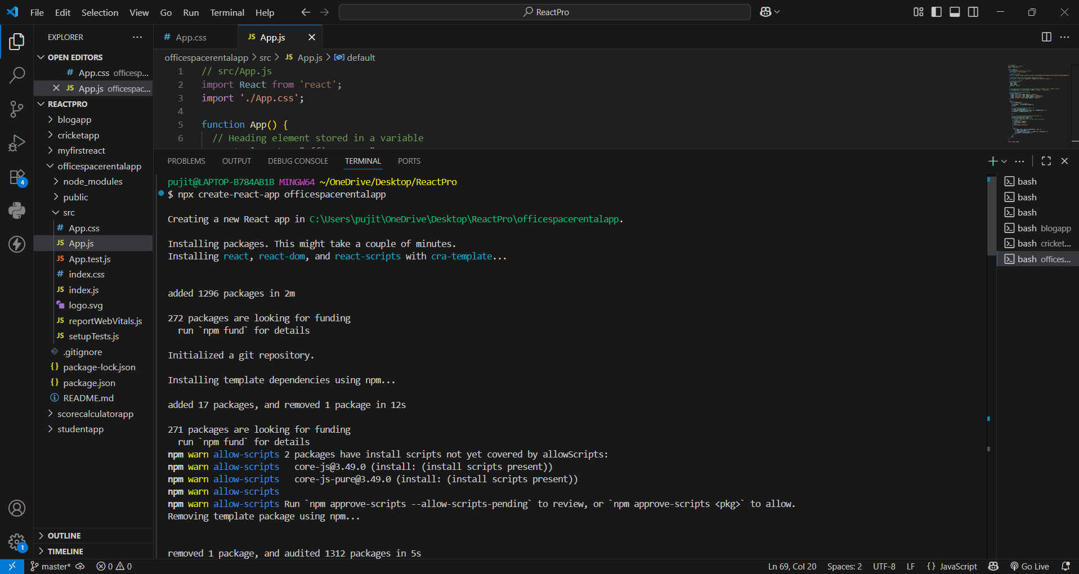
App.css :
.App {
padding: 20px;
font-family: Arial, sans-serif;
}

.textRed {
color: red;
}

.textGreen {
color: green;
}
App.js :
import React from 'react';
import './App.css';
function App() {
// Heading element stored in a variable
const element = "Office Space";
// Image source URL
const sr = "https://images.unsplash.com/photo-1497366216548-37526070297c?auto=format&fit=crop&w=500&q=80";
// Image JSX element with width, height, and alt attributes
const jsxatt = <img src={sr} width="25%" height="25%" alt="Office Space" />;
// Single Office Object
const ItemName = {
Name: "DBS",
Rent: 50000,
Address: "Chennai"
};
// Determine text color class based on rent threshold (<= 60000 is red, > 60000 is green)
let singleRentColor = ItemName.Rent <= 60000 ? 'textRed' : 'textGreen';

// Array list of Office Space Objects
const officeSpaces = [
{ Name: "DBS", Rent: 50000, Address: "Chennai" },
{ Name: "FastOffice", Rent: 75000, Address: "Bangalore" },
{ Name: "SmartSpace", Rent: 55000, Address: "Hyderabad" },
{ Name: "WorkSpot", Rent: 65000, Address: "Mumbai" }
];
return (
<div className="App">
{/* 1. Main Heading & Image */}
<h1>{element} , at Affordable Range</h1>
{jsxatt}
{/* 2. Single Office Details Display */}
<h1>Name: {ItemName.Name}</h1>
<h3 className={singleRentColor}>Rent: Rs. {ItemName.Rent}</h3>
<h3>Address: {ItemName.Address}</h3>
<hr />
{/* 3. List of Office Objects rendered using map() */}
<h2>More Available Office Spaces:</h2>
{officeSpaces.map((item, index) => {
// Evaluate conditional color for each item in the array
let colors = [];
if (item.Rent <= 60000) {
colors.push('textRed');
} else {
colors.push('textGreen');
}

return (
<div key={index} style={{ marginBottom: '20px' }}>
<h1>Name: {item.Name}</h1>
<h3 className={colors.join(' ')}>Rent: Rs. {item.Rent}</h3>
<h3>Address: {item.Address}</h3>
</div>
);
})}
</div>
);
}

export default App;

Running on localhost 3000 :
